Australian Islamic College 2018

ATAR Chemistry Units 3 and 4

Task 11 (Weighting: 5%)

Esters Validation Test

Test Time: 25 minutes

Please do not turn this page until instructed to do so.

First Name | Surname
ANSWERS

Teacher

Mark / 26 | Percentage

Equipment allowed: Pens, pencils, erasers, whiteout, rulers and non-programmable calculators permitted by the Schools Curriculum and Standards Authority.

- Which of these molecules is an ester? Circle the correct answer. [1 mark]

  - CH₃CHOHCH₂CH₃
  - CH₃COCH₃
  - CH₃CH₂COOCH₂CH₃
  - CH₃CH₂CHO

- This question relates to the ester shown below.
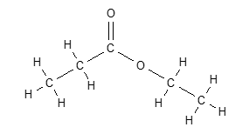

  - Draw the condensed structural formulae and give the names of the two organic molecules that would be required to synthesise this compound. [4 marks]

1.CH₃CH₂COOH [1]

Name: propanoic acid [1]

2. CH₃CH₂OH [1]

Name: ethanol [1]

- Methyl salicylate (oil of wintergreen or wintergreen oil) is an organic compound with the formula C₆H₄(OH)(CO₂CH₃). Methyl salicylate was synthesised in the laboratory by combining the appropriate alcohol and carboxylic acid.

  - Show the reaction that occurs during the synthesis of methyl salicylate. Draw structural formulae for all organic reactants and products. [2 marks]

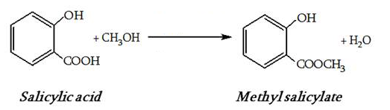

  - The test tube containing the reaction mixture was placed in a beaker of water. The beaker of water was then heated using a Bunsen burner.
      - Suggest why the reaction mixture was not heated directly using the Bunsen burner. [1 mark]

Because the reactants are flammable / to avoid the risk of a fire. Also accept to reduce the evaporation of volatile reactants.

      - What was the purpose of heating the reaction mixture? [1 mark]

To increase reaction rate.

  - Write observations for the reaction described above for the synthesis of oil of wintergreen. [2 marks]

A colourless liquid is combined with a white solid. The white solid disappears and the mixture remains colourless. A colourless immiscible layer appears above the colourless liquid. The odour of oil of wintergreen / a pleasant odour appears. Any 4, ½ each.

  - The reaction mixture was heated in an open test tube, however a better method would be to heat the reaction mixture in the reflux condenser shown below.

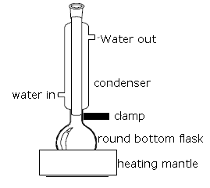
Explain the advantage of synthesising the ester using a reflux condenser. [2 marks]

The reactants are volatile and when heated will evaporate [1]. The reflux condenser will reduce the loss of reactants by condensing escaping gases [1].

  - Concentrated sulfuric acid was used as a catalyst. Explain how a catalyst increases reaction rate. [2 marks]

A catalyst increases reaction rate by lowering the activation energy [1] by providing an alternative reaction pathway [1]. Also accept a greater proportion of the reactant particles have the activation energy and/or there are more successful collisions.

  - An additional benefit of adding concentrated sulfuric acid to the reaction mixture is that it reacts with water in the reaction mixture to form a hydrated form of sulfuric acid, thereby effectively removing water from the reaction mixture. Explain the advantage of removing water from the reaction mixture. [2 marks]

This increases yield (1) by removing a product (1).

  - Identify two safety hazards associated with the synthesis of oil of wintergreen and for each explain how the risk of that hazard was minimised. [2 marks]

Any two reasonable answers, for instance:
Concentrated sulfuric acid is corrosive – wear gloves.
Ethanol is flammable – heat it in a hot water bath instead of directly on the Bunsen burner flame.

- Esters cannot form hydrogen bonds with other ester molecules but they can form hydrogen bonds with water molecules.

  - Explain why esters cannot form hydrogen bonds with other ester molecules. [1 mark]

They do not contain a hydrogen atom bonded to a highly electronegative atom.

  - Draw a diagram to represent a hydrogen bond between methyl ethanoate and water. [2 marks]

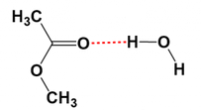

1 mark for methyl ethanoate. 1 mark for correct location of the hydrogen bond.

- Using structural formulae, write the equation for the saponification of a triglyceride. Show all reactants and products. You may use ‘R’ to represent long hydrocarbon chains. [2 marks; 1 mark off per mistake]

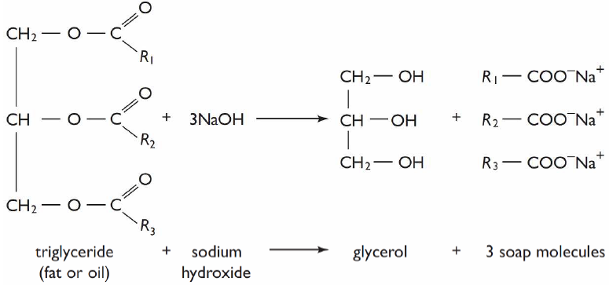

- Name the products A and B produced by the reaction below. [2 marks]

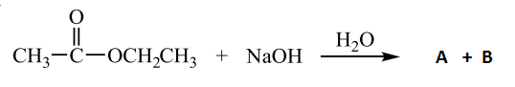

Product A: Ethanol (1)

Product B: Sodium ethanoate (accept ethanoate ion) (1)

END OF PAPER

